

SPANISH
CLASSES
Learning Language
Tel: (661) 210-5038
Fax: (323) 261-4692
E-mail:admin@learninglanguageswithus.com
www.learninglanguageswithus.com

“I enjoy the personalized attention that you get in the class. You can go at you own pace and Edwin takes as much time as necesary to make sure you understand new concepts”

- Spencer Hamer
Attorney At Law

“The hour and a half of Spanish class goes by very quickly. It's a very relaxed atmosphere and a fun learning experience. Edwin is very quick to give us a word or phrase that helps us complete and express our ideas”

- Georgia and Elliott Lawrence

“I am learning Spanish and I really like the comfortable atmosphere. Classes are very enjoyable and go by quickly. Even after a long day, the class energizes and excites me. Whenever I have questions or topics I want to talk about, they are always answered and discussed, so it personalizes the classes more and I get a lot out of them”

- Stephanie.

Contact Edwin Today:
Learning Language
Tel: (661) 210-5038
Fax: (323) 261-4692
E-mail:admin@learninglanguageswithus.com
www.learninglanguageswithus.com
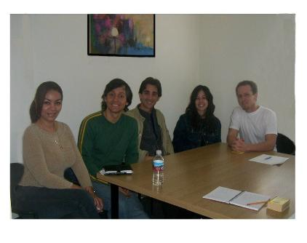

Learning Language
Learn Spanish to communicate at work, traveling or for fun
L

L
Edwin Portillo
LEARNING LANGUAGE
Instructor
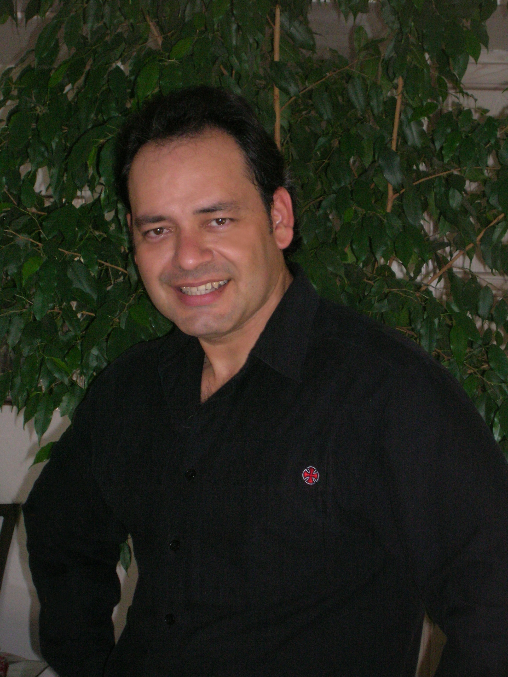
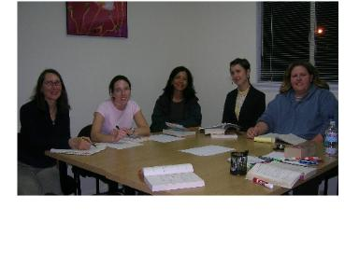
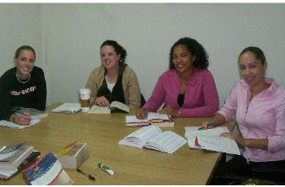
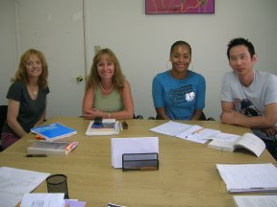

Learning Language offers customized one-on-one conversational Spanish classes according to your needs and small groups, also Corporate Spanish according to your business needs with an experienced native Spanish speaker Instructor. We believe that small groups and individual classes allow maximum interaction between Student and Instructor and provide plenty of opportunity to participate and interact. Our Spanish classes provides the structural and cultural nuances needed to express yourself in real life situations, whether your goal is to learn Spanish to communicate at work, traveling, or for fun.

GROUP CLASSES
Group classes are placed at:

1012 S. Robertson Blvd. Suite C
Los Angeles CA 90035

SMALL GROUP CLASSES PRICE

8 sessions, each session is 1 hour and fifteen minutes once a week. Maximum 10 students per class.

By March 24, 2008……….………$ 199.00
After March 24, 2008…………….$ 219.00

INDIVIDUAL CLASSES

Please call for information.
You determine the frequency and duration of your session.

Meeting Locations
Our face to face Spanish classes take place at centric locations such as:
Centric cafes, your home, your office. We conduct Spanish classes in Los Angeles County. For Corporations, we conduct classes in Los Angeles County and Ventura County.

Spanish Classes at Café
Cafes offer you a relaxed atmosphere much different that you may encounter in a classroom setting. Enjoy a coffee or tea and have a nice moment while you learn.

Spanish Classes at Home
Spanish class at your home or your office. Avoid the traffic and save time!!! Feel comfortable meeting with your tutor at your home, this offers you the maximum of convenience for you.
EXACT DATES TERM
March 31, 2008 to May 24, 2008

SPANISH CLASSES
DAY | MARCH | APRIL | MAY
Mon | 31 | 7, 14, 21, 28 | 5, 12, 19
Wed |  | 2, 9, 16, 23, 30 | 7, 14, 21
Sat |  | 5, 12, 19, 26 | 3, 10, 17, 24

SCHEDULES
March 31, 2008 to May 24, 2008

LEVEL | DAY | TIME
Beginning A | Mon  Wed  Sat | 7:00pm - 8:15pm  7:00pm - 8:15pm  9:am -10:15am
Beginning C | Mon | 8:20pm – 9:35pm
Intermediate | Wed | 8:20pm – 9:35pm
Advanced |  | Please call for information


LEARNING LANGUAGE
Classes can be arranged at any time
Spanish classes are offer in all levels for beginner, intermediate and advanced.

- Guided conversation
- Listening Comprehension
- Literature
- Songs
- Videos

Learning Language offers you a flexible schedule for your busy life style.

You can choose the schedule at your convenience. Contact us for more information

NO REGISTRATION FEE

MATERIAL
The textbook costs between $ 18.00 and $35.00, includes beginning level lessons and intermediate level lessons. For advanced classes we provide material at no cost.

DISCOUNT
For each additional class you take in the same term, you receive a $20.00 discount.

REFUNDS
Fees are only refundable or creditable when the school is notified twenty-four hours after the first scheduled class.

If you are unable to attend a class in your regular schedule, you can schedule a make-up session ($29.00).

